Assessing stress in Arctic lemmings: fecal metabolite levels reflect plasma free corticosterone levels

Online resources

Appendix A. Model selection for blood and FCM analyses.

Table A1. Ranking of models testing for the effect of various factors on initial (t = 0) samples, samples taken 30 min after capture, and relative change (r, ratio between values at t = 30 and t = 0). Variables include total and free corticosterone (total.c and free.c), maximum corticosterone binding capacity (mcbc), and glucose concentrations (g). Model selection is based on the Akaike’s second-order criterion (AICc). The number of parameter (K), the degrees of freedom (df), ΔAICc and adjusted R² are reported for each model.
Response variable | Model | Comparison | K | df | ΔAICc | R²
total.c₀ | 1 | group | 4 | 16 | 0.00 | 0.82
 | 3 | sex+repro+sex*repro | 5 | 15 | 11.24 | 0.72
 | 4 | intercept (null) | 2 | 18 | 28.97 | ‒
 | 2 | repro | 3 | 17 | 31.00 | 0.00
total.c₃₀ | 1 | group | 4 | 15 | 0.00 | 0.73
 | 3 | sex+repro+sex*repro | 5 | 14 | 5.30 | 0.69
 | 4 | intercept (null) | 2 | 17 | 19.87 | ‒
 | 2 | repro | 3 | 16 | 20.80 | 0.05
r_{total.c} | 1 | group | 4 | 14 | 0.00 | 0.36
 | 4 | intercept (null) | 2 | 16 | 3.30 | ‒
 | 2 | repro | 3 | 15 | 5.04 | 0.01
 | 3 | sex+repro+sex*repro | 5 | 13 | 7.70 | 0.15
mcbc₀ | 1 | group | 4 | 15 | 0.00 | 0.74
 | 3 | sex+repro+sex*repro | 5 | 14 | 2.95 | 0.73
 | 4 | intercept (null) | 2 | 17 | 20.02 | ‒
 | 2 | repro | 3 | 16 | 22.47 | 0.00
mcbc₃₀ | 1 | group | 4 | 15 | 0.00 | 0.78
 | 3 | sex+repro+sex*repro | 5 | 14 | 1.88 | 0.79
 | 4 | intercept (null) | 2 | 17 | 22.97 | ‒
 | 2 | repro | 3 | 16 | 24.41 | 0.02
r_{mcbc} | 4 | intercept (null) | 2 | 15 | 0.00 | 0.00
 | 2 | repro | 3 | 13 | 2.15 | 0.00
 | 3 | sex+repro+sex*repro | 5 | 12 | 3.21 | 0.24
 | 1 | group | 4 | 14 | 5.05 | 0.00
free.c₀ | 1 | group | 4 | 15 | 0.00 | 0.22
 | 4 | intercept (null) | 2 | 17 | 0.56 | ‒
 | 2 | repro | 3 | 16 | 3.47 | 0.00
 | 3 | sex+repro+sex*repro | 5 | 14 | 8.97 | 0.00
free.c₃₀ | 4 | intercept (null) | 2 | 17 | 0.00 | ‒
 | 2 | repro | 3 | 16 | 2.86 | 0.00
 | 1 | group | 4 | 15 | 5.71 | 0.00
 | 3 | sex+repro+sex*repro | 5 | 14 | 10.06 | 0.00
r_{free.c} | 4 | intercept (null) | 2 | 15 | 0.00 | ‒
 | 2 | repro | 3 | 14 | 2.87 | 0.00
 | 1 | group | 4 | 13 | 6.65 | 0.00
 | 3 | sex+repro+sex*repro | 5 | 12 | 10.65 | 0.00
g₀ | 3 | sex+repro+sex*repro | 5 | 15 | 0.00 | 0.41
 | 2 | repro | 3 | 17 | 0.84 | 0.21
 | 4 | intercept (null) | 2 | 18 | 3.60 | ‒
 | 1 | group | 4 | 16 | 6.03 | 0.08
g₃₀ | 4 | intercept (null) | 2 | 17 | 0.00
 | 1 | group | 4 | 15 | 1.19 | 0.15
 | 2 | repro | 3 | 16 | 2.82 | 0.00
 | 3 | sex+repro+sex*repro | 5 | 14 | 7.04 | 0.00
r_{g} | 1 | group | 4 | 14 | 0.00 | 0.33
 | 4 | intercept (null) | 2 | 16 | 2.59 | ‒
 | 2 | repro | 3 | 15 | 2.87 | 0.09
 | 3 | sex+repro+sex*repro | 5 | 13 | 9.51 | 0.01
Note: group = juvenile (females < 28 g, males < 30 g), adult females and adult males; repro = reproductively active vs inactive (used as the reference group).

Table A2. Ranking of models quantifying the effects of individual covariates on fecal corticosterone metabolites concentrations (fcm). Model ranking is based on the Akaike’s second-order criterion (AICc). The number of parameter (K), the degrees of freedom (df), ΔAICc and adjusted R² are reported for each model.
Response variable | Model | Comparison | K | df | ΔAICc | R²
fcm₀ | 1 | group | 4 | 16 | 0.00 | 0.12
 | 2 | repro | 3 | 17 | 0.48 | 0.00
 | 4 | intercept (null) | 2 | 19 | 0.77 | ‒
 | 3 | sex+repro+sex*repro | 5 | 15 | 5.46 | 0.00
fcm_{max} | 3 | sex+repro+sex*repro | 5 | 14 | 0.00 | 0.50
 | 2 | repro | 3 | 16 | 1.17 | 0.30
 | 1 | group | 4 | 15 | 2.22 | 0.34
 | 4 | intercept (null) | 2 | 17 | 5.79 | ‒
r_{fcm} | 4 | intercept (null) | 2 | 17 | 0.00 | ‒
 | 2 | repro | 3 | 16 | 0.83 | 0.05
 | 1 | group | 4 | 15 | 4.39 | 0.00
 | 3 | sex+repro+sex*repro | 5 | 14 | 5.64 | 0.06
Note: group = juvenile (females < 28 g, males < 30 g), adult females and adult males; repro = reproductively active vs inactive (used as the reference group).

Appendix B. FCM concentrations measured by two different enzyme immunoassays cross-reacting with different metabolites.

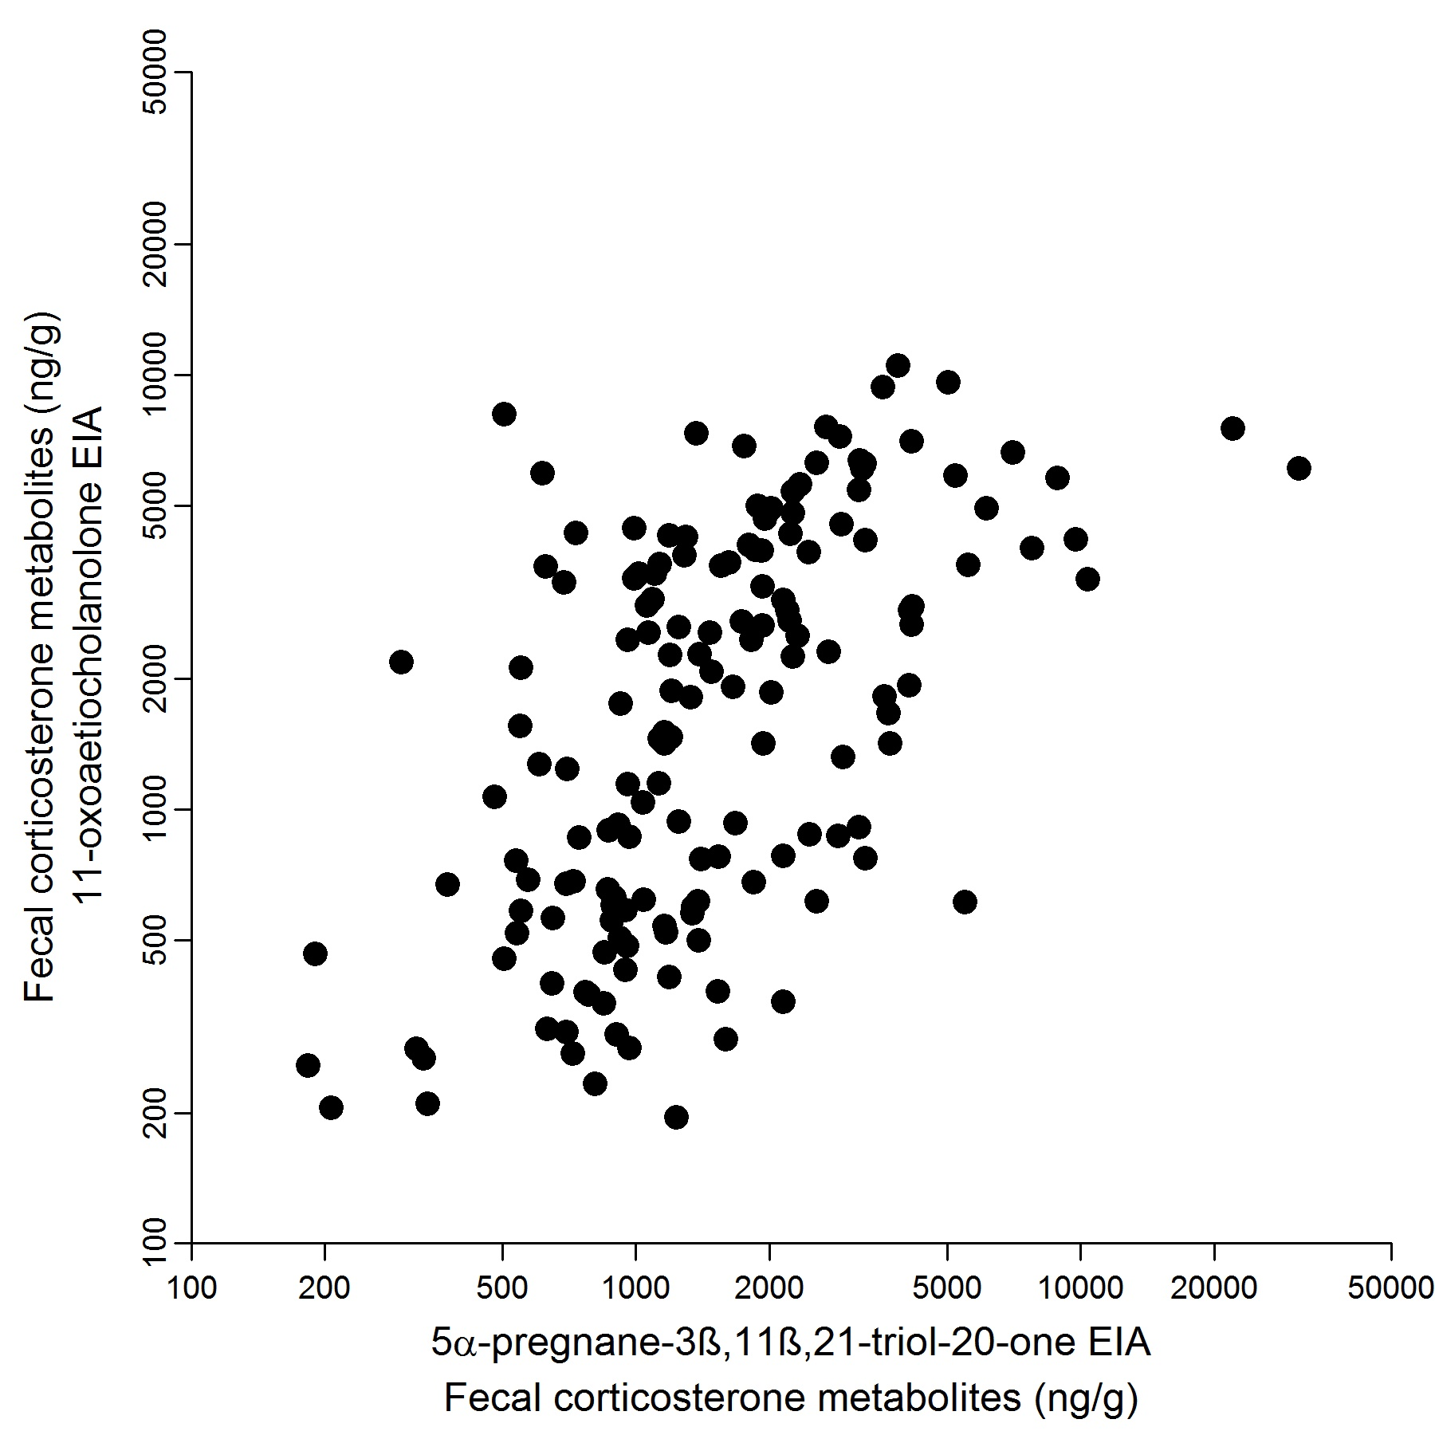
Figure B1. Correlation between concentrations of fecal corticosterone metabolites (FCM) measured by enzyme immunoassays using two different antibodies. Concentrations were correlated on the ln-scale (Pearson r = 0.58, p < 0.001). Measurements of FCM concentrations with both assays were performed on 9 different lemmings with 10 to 21 samples each (total n = 308).

Appendix C. Temporal corticosterone metabolite profiles in feces of individual lemmings in captivity.
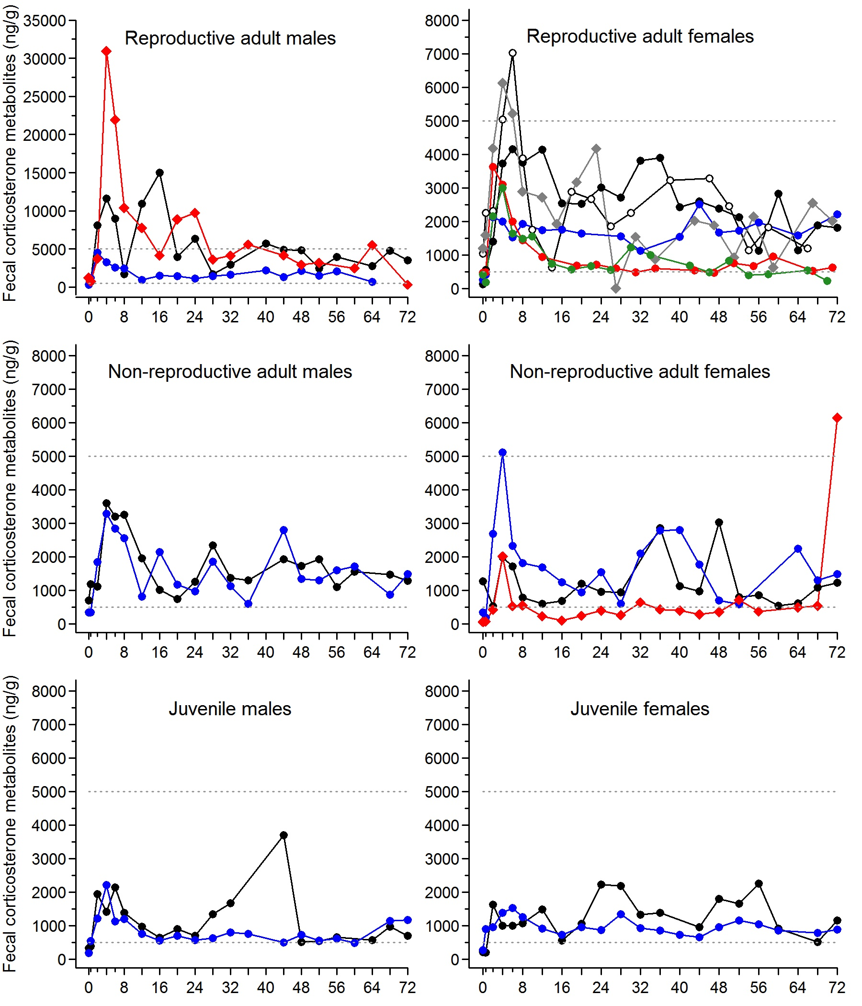
Figure C1. Time series of fecal corticosterone metabolites concentrations of lemmings (each line represent one individual) measured by enzyme immunoassay (see methods). Each panel represent a category of lemming based on age, sex, and reproductive condition. Lemmings were captured at time 0 and released 72 h later.

Appendix D. Effects of age, sex, and reproductive condition on the relationship between FCM and plasma corticosterone.

Analyses of the relationship between fecal corticosterone metabolites (FCM) and plasma total or free corticosterone revealed that the former was weak ($R_{m}^{2}$ = 0.02) while the latter was fairly strong ($R_{m}^{2}$ = 0.53). Higher variability among sexes or reproductive conditions in total corticosterone compared to free corticosterone could be responsible for this difference. In order to examine this question, we built a set of 6 candidate models that included the additive effects of either group (adult males, females and juveniles) or sex and reproductive condition in combination with plasma corticosterone concentration (tables D1 and D2). We calculated the total $R_{m}^{2}$ of each model ($R_{f}^{2}$) as well as the partial $R_{m}^{2}$ ($R_{p}^{2}$) associated with either total or free corticosterone, our variables of primary interest. Partial $R_{m}^{2}$ were calculated by the difference between the $R_{m}^{2}$ of the full model (estimated by the method of Nakagawa and Schielzeth (2013) for mixed models) and the $R_{m}^{2}$ of a simplified model without the total or free corticosterone covariate.
Including a group effect in the model allowed us to uncover a significant relationship between FCM and total corticosterone but the latter variable explained a fairly small proportion of the variance ($R_{p}^{2}$ = 0.18; tables D1 and D3, fig. D1). For free corticosterone, the preferred model included additive effects of sex and reproductive condition and this model again revealed a strong relationship between FCM and free corticosterone concentrations, with the latter variable still explaining a very high proportion of the variability in FCM ($R_{p}^{2}$ = 0.55; tables D2 and D4; fig. D1). Therefore, even when controlling for differences among sexes or reproductive condition, free corticosterone explained a much higher proportion of variance in FCM than total corticosterone.

Reference
Nakagawa S. and H. Schielzeth. 2013. A general and simple method for obtaining R² from generalized linear mixed-effects models. Methods Ecol Evol 4:133‒142. doi:10.1111/j.2041-210x.2012.00261.x

Table D1. Ranking of models quantifying the relationship between FCM and total corticosterone (total.c) with individual covariates. Mixed-effects models were used with individual lemmings as the random variable. The partial marginal coefficients of determinations for the total corticosterone covariate ($R_{p}^{2}$) and the coefficient for the full model ($R_{f}^{2}$) are presented.
Model | K | ΔAICc | $$R_{p}^{2}$$ | $$R_{f}^{2}$$
total.c + group | 6 | 0.00 | 0.18 | 0.28
total.c + sex | 5 | 0.14 | 0.15 | 0.22
total.c + sex*repro | 7 | 1.27 | 0.21 | 0.32
total.c + sex + repro | 6 | 2.54 | 0.12 | 0.23
null | 3 | 3.16 | - | -
total.c | 4 | 5.19 | - | 0.02
total.c + repro | 5 | 6.67 | 0.01 | 0.05
Note: group = juvenile, adult females and adult males; repro = reproductively active vs inactive (used as the reference group).

Table D2. Ranking of models quantifying the relationship between FCM and free corticosterone (free.c) with individual covariates. Mixed-effects models were used with individual lemmings as the random variable. The partial marginal coefficients of determination for the free corticosterone covariate ($R_{p}^{2}$), and the coefficient for the full model ($R_{f}^{2}$) are presented.
Model | K | ΔAICc | $$R_{p}^{2}$$ | $$R_{f}^{2}$$
free.c + sex + repro | 6 | 0.00 | 0.55 | 0.66
free.c + sex + repro + sex*repro | 7 | 1.41 | 0.57 | 0.68
free.c + group | 6 | 2.95 | 0.53 | 0.63
free.c + sex | 5 | 3.11 | 0.53 | 0.60
free.c + repro | 5 | 4.14 | 0.54 | 0.59
free.c | 4 | 5.98 | - | 0.53
null | 3 | 29.01 | - | -
Note: group = juvenile, adult females and adult males; repro = reproductively active vs inactive (used as the reference group).

Table D3. Effects retained in the most parsimonious model (table D1) testing the relationship between FCM and total corticosterone (total.c) while considering individual covariates.
Parameter | β | Low CI | High CI
total.c | 0.67 | 0.19 | 1.15
group (J – AF) | 1.25 | -0.34 | 2.84
group (AM – AF) | 2.57 | 0.97 | 4.18
Note: J = juvenile; AF = adult females; AM = adult males.

Table D4. Effects retained in the most parsimonious model (table D2) testing the relationship between FCM and free corticosterone (free.c) while considering individual covariates.
Parameter | β | Low CI | High CI
free.c | 0.43 | 0.31 | 0.55
sex | 0.77 | 0.19 | 1.36
repro | 0.69 | 0.12 | 1.26
Note: sex = males and females (used as the reference group); repro = reproductively active vs inactive (used as the reference group).

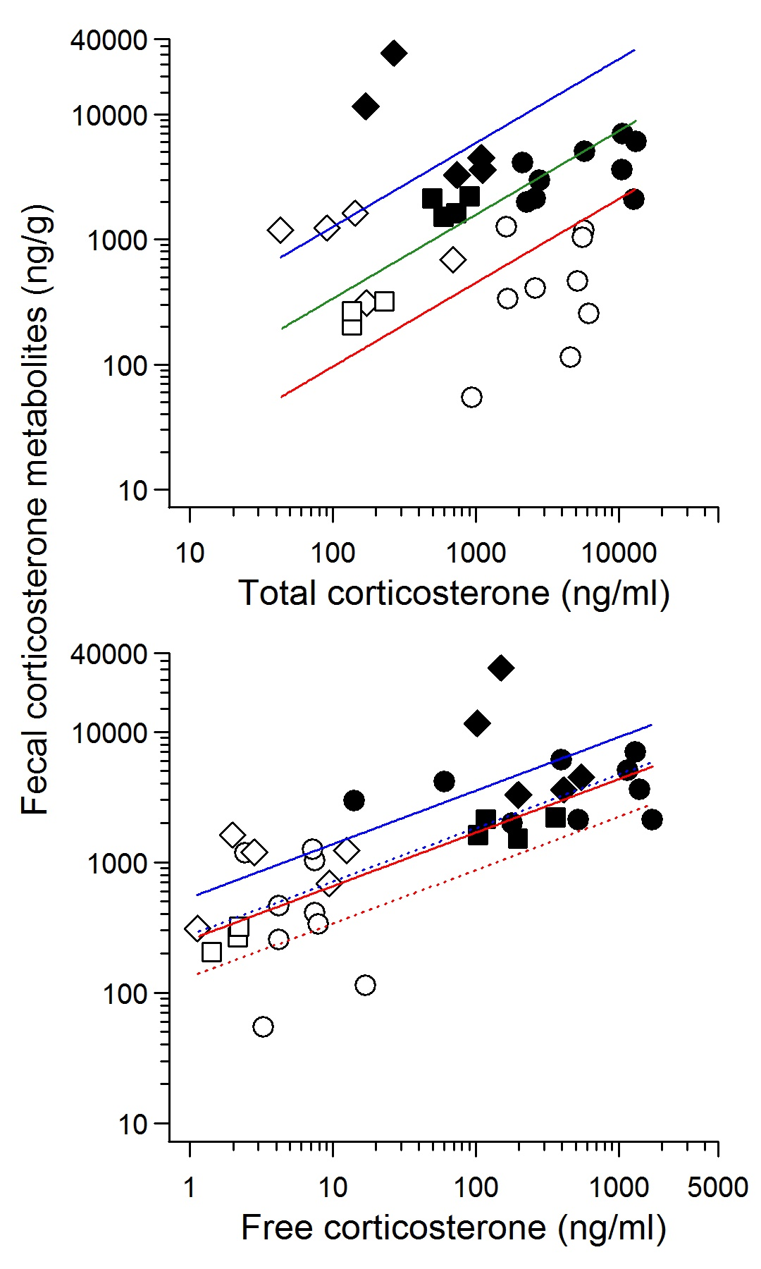
Figure D1. Relationships between plasma total or free corticosterone and FCM concentrations in lemmings when considering individual covariates. Estimates are based on models presented in tables D3 and D4. Samples collected at t = 0 for plasma and FCM were paired (white points) whereas plasma samples collected at t = 30 min were paired with maximal FCM concentrations recorded (i.e. between 2 to 6 h after capture depending on each individual; black points). Two observations (one for each paired samples) per lemming (n = 18) were used to assess the relationship. Circles = adult females; diamonds = adult males; squares = juveniles. Top figure: blue line = adult males; green line = juveniles; red line = adult females. Bottom figure: blue solid line = reproductive males; blue dotted line = non-reproductive male; red solid line = reproductive females; red dotted line = non-reproductive females.

