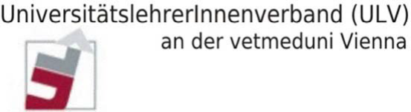

MEMBERSHIP DECLARATION

I herewith declare my membership to the University Teachers’ Association (UniversitätslehrerInnenverband – ULV) at the University of Veterinary Medicine, Vienna (ULV-vetmeduni).

Name

Institute/Clinic

Vienna,
(Date) (Signature)

Please return the filled-in form to Dr. Katharina Hittmair
Klinische Abteilung für Bildgebende Diagnostik
katharina.hittmair@vetmeduni.ac.at

